**THO Deployment Document**

Below pre-requisites must be followed before THO NUnit Testcase suite execution:

Steps as below:

* Open THO automation project and click on “Philips.PmsMR.Serviceability.THO.Verification.sln” to Launch Visual studio 2015. 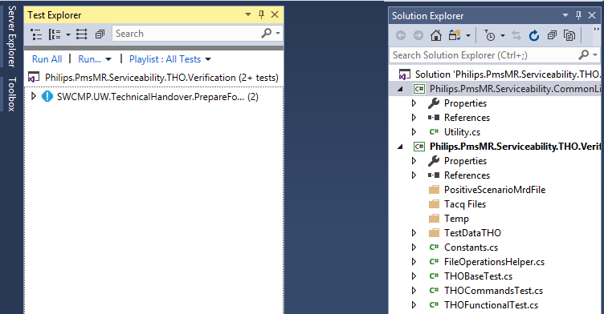
* Right click on "Projects-->Properties" to select target framework as 4.5.2 as shown below:

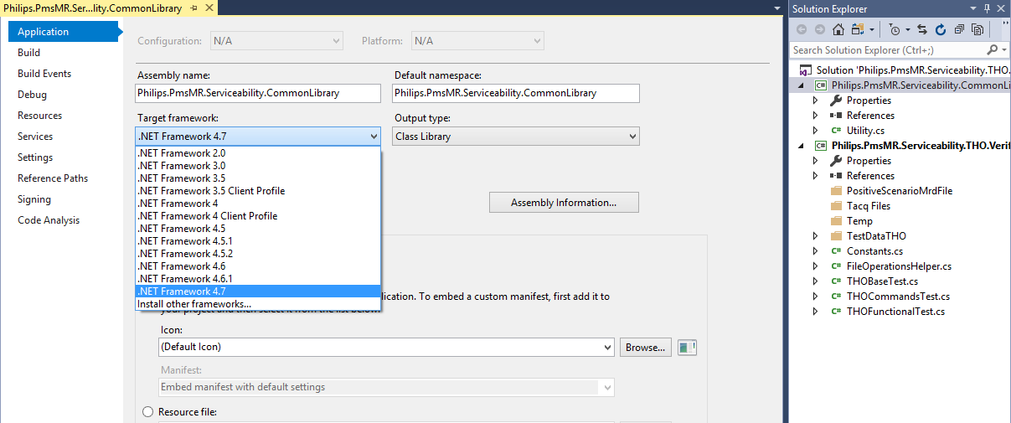

* Clean and Build the solution, click on output and copy the path to select the "Philips.PmsMR.Serviceability.THO.Verification.dll" Example shown in below fig.

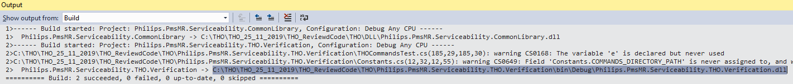

* Launch NUnit 2.6.2 from below path (“C:\Program Files (x86) \NUnit2.6.2\bin\NUnit-86.exe”) 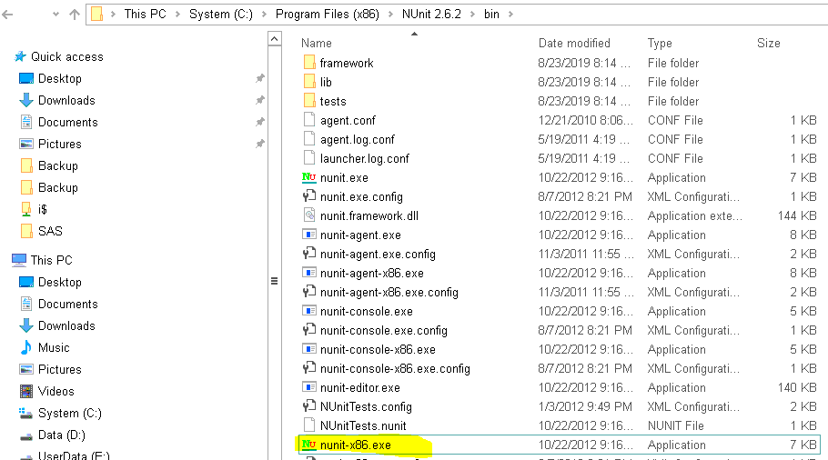
* Select "File-->New Project" (For the first time to open Nun it) and search the above copied file to select "Philips.PmsMR.Serviceability.THO.Verification.dll" and click on 'yes'
* Select "File-->Reload Project" to load all the tests into nun it as shown below

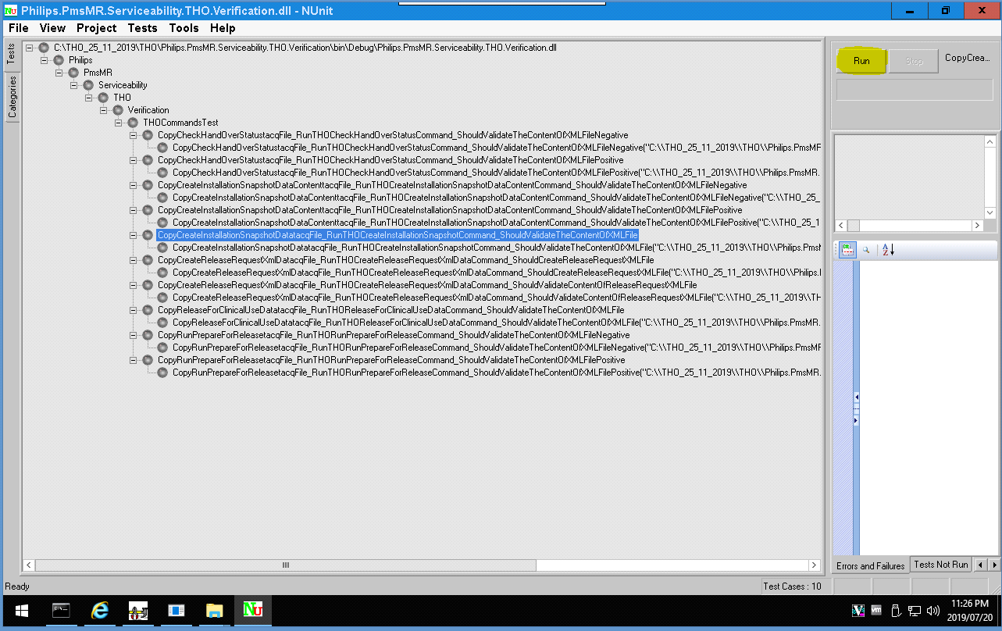

* To Run all the test cases, select "THOCommandsTest" and click on "Run" button
* To Run the selected test cases, right click on NUnit screen and click on Show CheckBoxes check box and select the test/s which ever needs to be executed.

**Debug Test Case:**

* To Debug test case build (Debug pointer should be kept) solution and select "Debug-->Attach Process" and select NUnit-agent-x86.exe and click on attach as shown below, open NUnit and run the test case

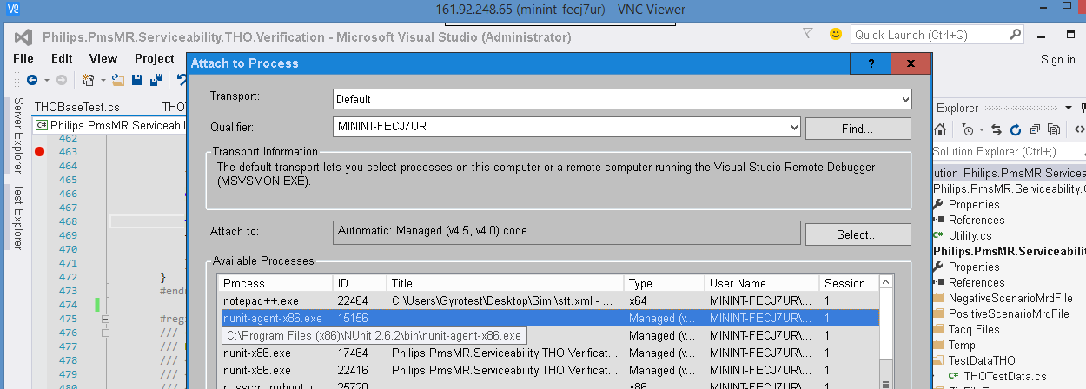

* Failed test case root cause you can find in right pane of NUnit as shown below

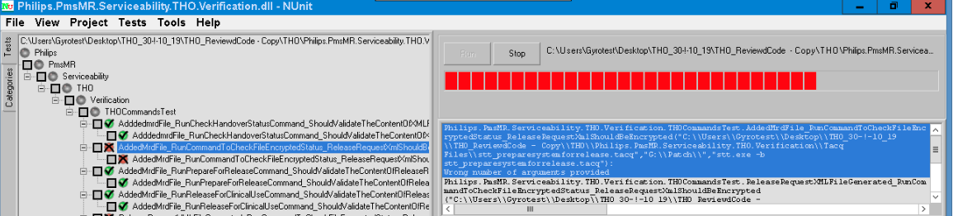

* Once all test cases executed NUnit generates result.xml report.

Note:

* Mrd files and tacq files are part of solution already kept in below respective folders
* Mrd files: 'PositiveScenarioMrdFile' and ‘NegativeScenarioMrdFile' folders
* Tacq files: 'Tacq Files' folder